**SERIS**

Solar Energy Research Institute Singapore



Cloud Based Real-time Analytical Monitoring of Photovoltaic Systems and Weather Parameters Project

High Level Design (HLD)

|  |  |
| --- | --- |
| Filing Reference | SE25PT7SERIS/TECH/DESIGN/HLD/HLD.doc |
| Document Title | High Level Design (HLD) |
| Version | 1.0 |
| Author | Treza Bawm Win |
| Date Created | 14/03/2018 |

|  |  |  |
| --- | --- | --- |
| **Approved by:** | | |
| Name | Designation | Date |
|  |  |  |
| **Authorized by:** | | |
| Name | Designation | Date |
|  |  |  |

**Revision History**

|  |  |  |  |
| --- | --- | --- | --- |
| **Revision** | **Date** | **Author** | **Description** |
| 1.0 | 14/03/2018 | Treza Bawm Win | Initial version |
| 1.1 | 25/03/2018 | Treza Bawm Win | * Product vision * Multitier arch * Technologies stack * Performance |
|  |  |  |  |
|  |  |  |  |
|  |  |  |  |
|  |  |  |  |
|  |  |  |  |
|  |  |  |  |
|  |  |  |  |
|  |  |  |  |
|  |  |  |  |
|  |  |  |  |
|  |  |  |  |
|  |  |  |  |
|  |  |  |  |

|  |  |  |  |
| --- | --- | --- | --- |
| **For Internal use** | | **Date** | **Department** |
| Authorized By |  |  |  |
| Released By |  |  |  |

Table of Contents

1 Introduction 4

1.1 Product Perspective 4

2 System Architecture 5

2.1 End to End architecture in diagram 5

2.2 Multitier Architecture 6

2.3 Technologies 6

2.3.1 AWS IoT 6

2.3.2 AWS Lambda 6

2.3.3 DynamoDB 6

2.3.4 AWS SNS 6

2.3.5 AWS Containers 7

2.3.6 Backend Web-Service API 7

2.3.7 Front-end web application 7

2.3.8 Chart Libraries 7

2.3 Application architecture 7

2.4 System Interactions (Sequence Diagrams) 7

2.5 Database design 7

2.6 Coding standards and packaging 8

2.7 Performance 8

1. Introduction

This document describes how the modules interact each other in a high level perspective. It also clearly states the detail necessary design model and architecture design prior to the actual implementation or coding. The architecture proposed in this document is designed to address the demand for the performance as well as the scalability and high availability.

## Product Perspective

As the SERIS is a real-time cloud based analytical monitoring system, the system is required to be designed with the vision of handling a very high range of real-time data transaction per second. The AWS cloud services are thus to be chosen as the pivot integrator of the components included within the project which would come with the options to support the system to be highly scalable and available.

On the other hands, the web-based system will be required to develop which will allow multiple concurrent different type of users to access the system in order to see live analytical data in a very good graphical user interface(GUI).

1. System Architecture

## End to End architecture in diagram

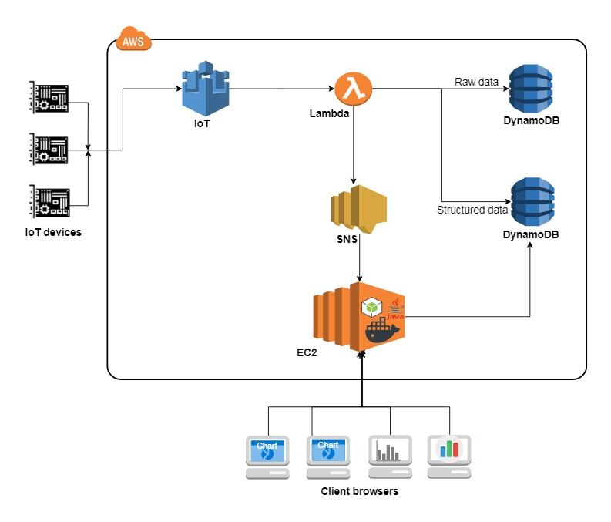

## Multitier Architecture

1. **Presentation Layer**: the web application will be implemented in Angular platform.
2. **Business Layer**: Java back-end application which has business process handlings and expose as REST web services.
3. **Data access Layer**: will be implemented using JDBC with DAO pattern.

## Technologies

### AWS IoT

Amazon Web Services (AWS) IoT service will be deployed in order to get data from the client’s IoT devices to AWS cloud for data persisting to database(DynamoDB) and further data processing in a secure way.

### AWS Lambda

The powerful Amazon Lambda service is chosen to persist the raw data from the IoT devices to database and compute the data for the client web browsers for displaying purpose. The AWS lambda will be taking care of the system’s administrative activities including operating system, scaling, code monitoring and logging.

### DynamoDB

In the vision of fully managed cloud database which is fast and flexible NoSql database service application, the Amazon DynamoDB is chosen to persist the raw and structured data from IoT devices.

### AWS SNS

Amazon SNS will be in charge of delivering data messages to multiple client browsers in order to obtain live data messages from the IoT devices in timely manner.

### AWS Containers

Amazon Elastic Compute Cloud (Amazon EC2) provides scalable computing capacity in the AWS cloud. Using Amazon EC2 eliminates the need to invest in hardware up front, so the development and deployment of applications will be faster. It also allows to launch as many or as few virtual servers as needed, configure security and networking, and manage storage.

### Backend Web-Service API

Java web application using Spring application framework will perform business logic and create, update, delete and retrieve from Dynamo DB. The app will expose the business services as REST web services API by running it in JBoss application server.

### Front-end web application

User interfaces will be designed to develop in JavaScript using Angular platform. The JavaScript client application will also be calling to the web application which hosts REST web service API for the data processing to Dynamo DB. Streaming of live data to the each front-end browsers is required and the web application therefore will be necessary of processing the live data sent from AWS SNS service.

### Chart Libraries

JavaScript charting libraries will be used as tools to visualize live weather data parameters in the form of beautiful, easy to understand, interactive way in the client user interface.

## 2.3 Application architecture

Insert Overview Use-Case diagram here …

## 2.4 System Interactions (Sequence Diagrams)

To be continue in design phase …

## 2.5 Database design

To be continue in design phase …

## 2.6 Coding standards and packaging

To be continue in design phase …

## 2.7 Performance

The system is required to collect data from every IoT devices from the station. Each station is equipped with two devices per now. As for the first implementation phase, the system needs to process data for the total 5 stations. However, it is necessary to design to perform X number of devices as the number of stations will be increased.